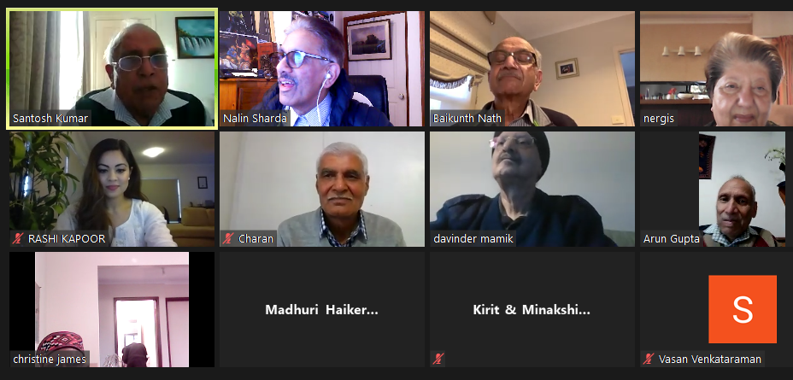

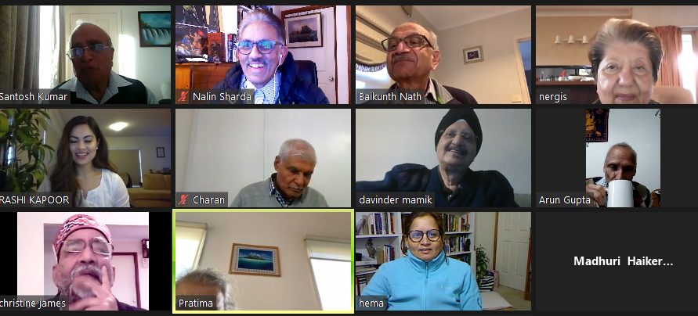
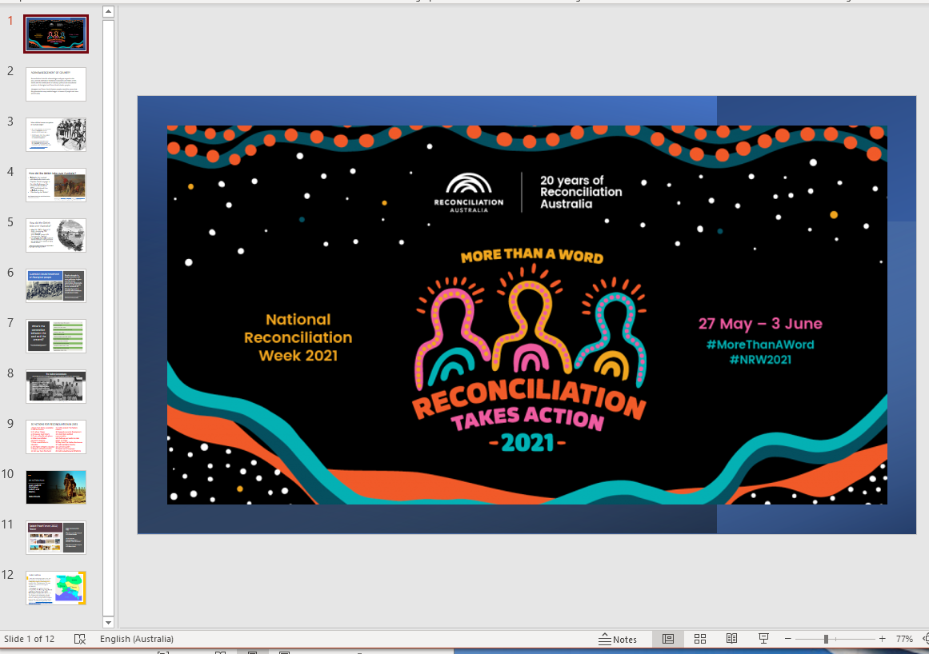
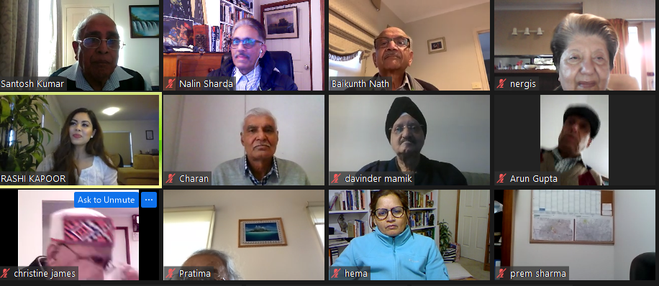
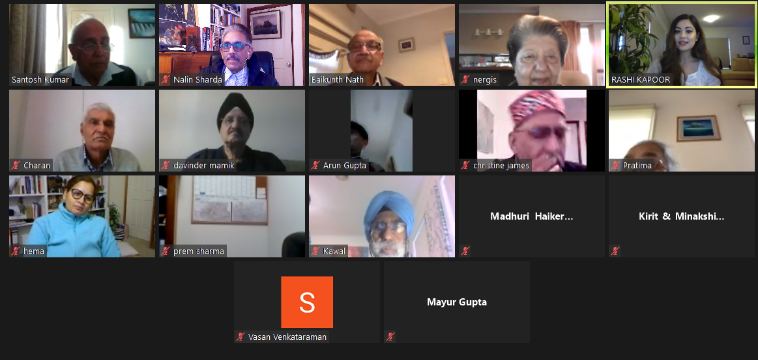

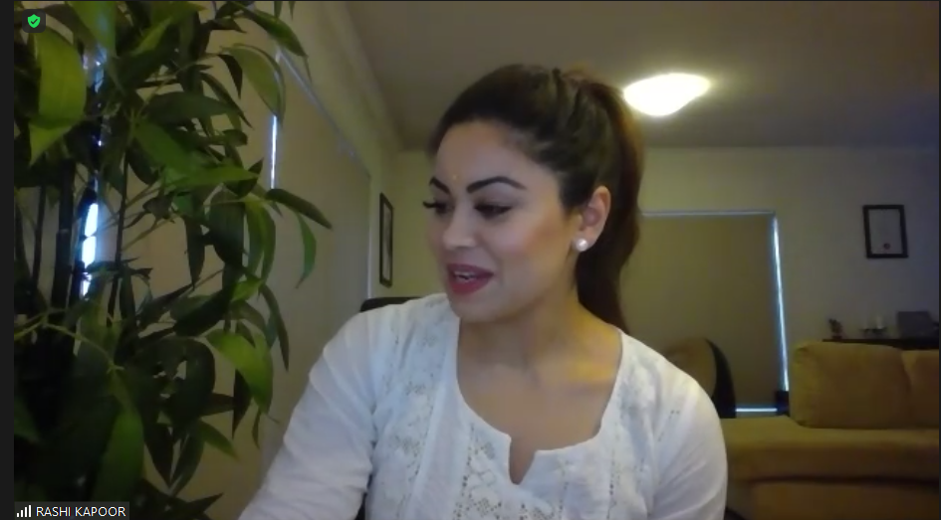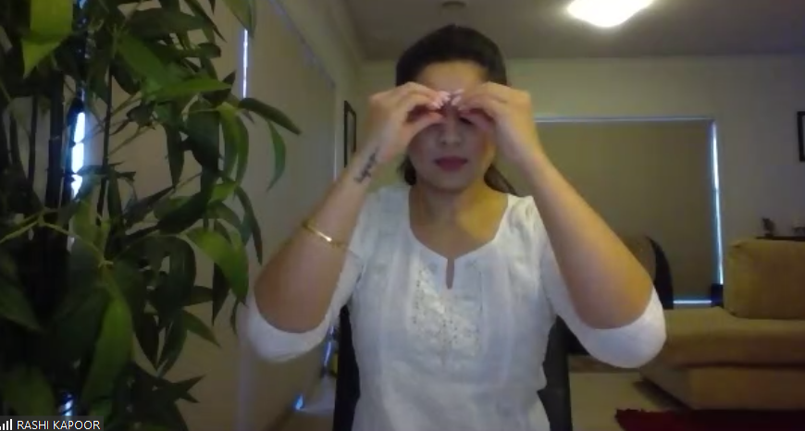
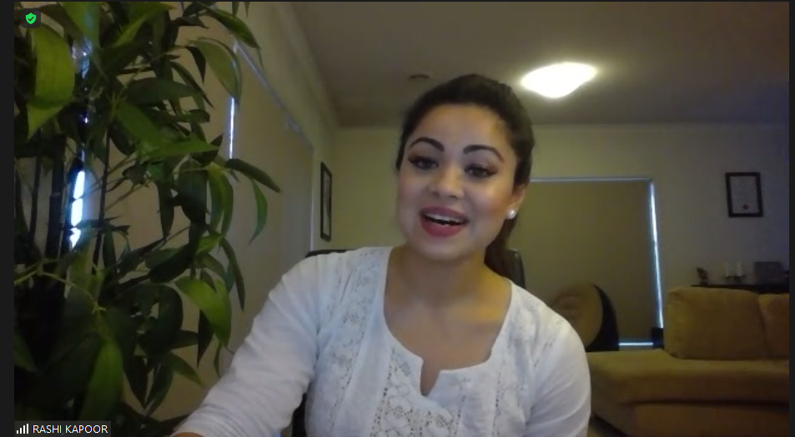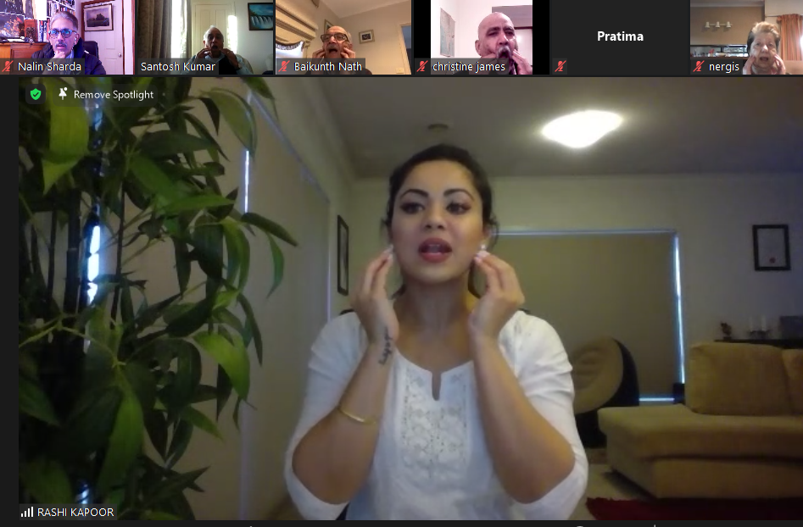
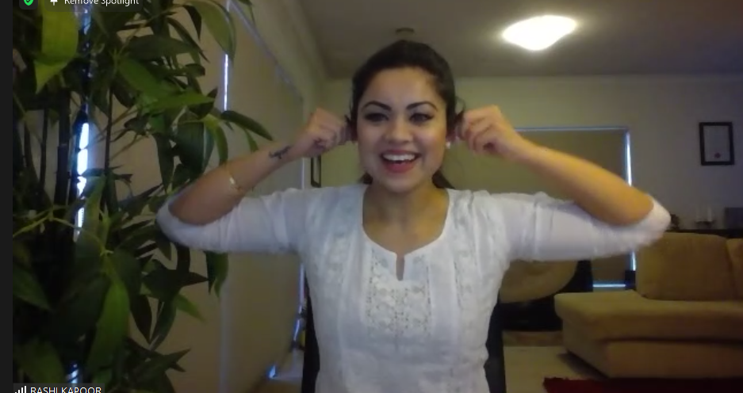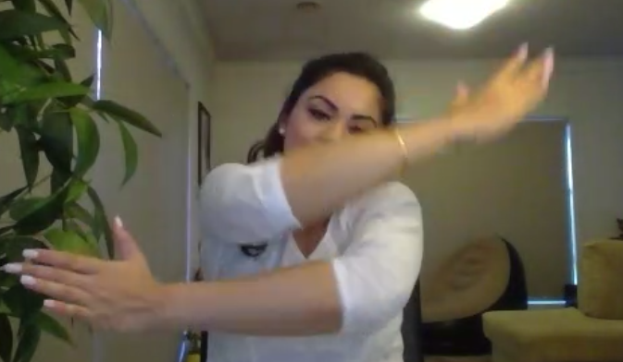

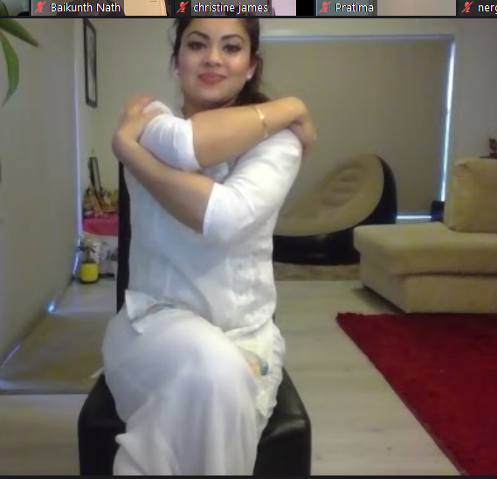
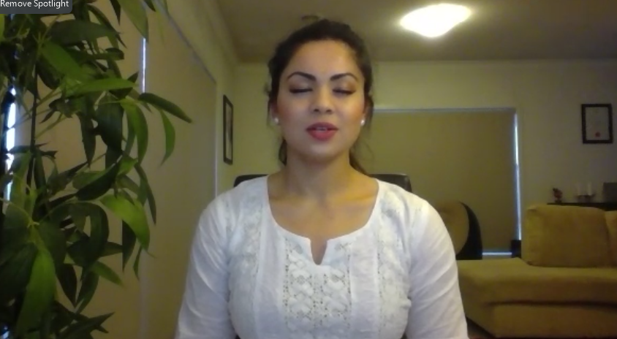

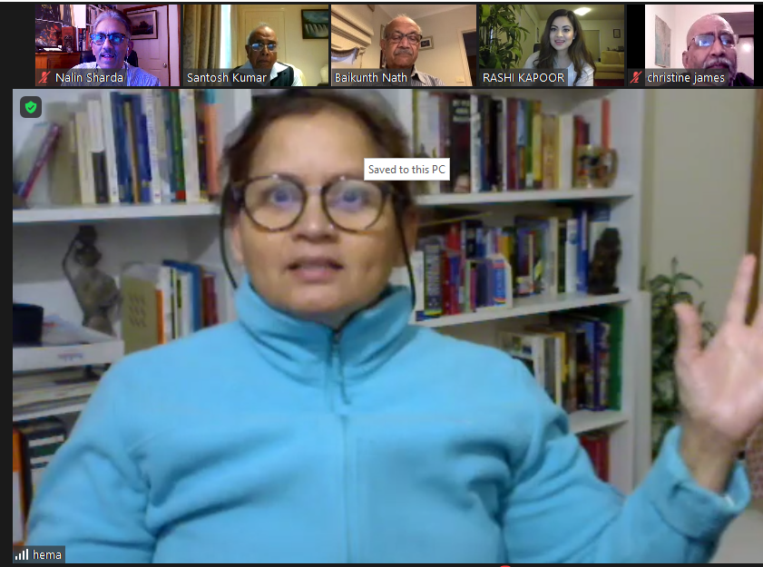
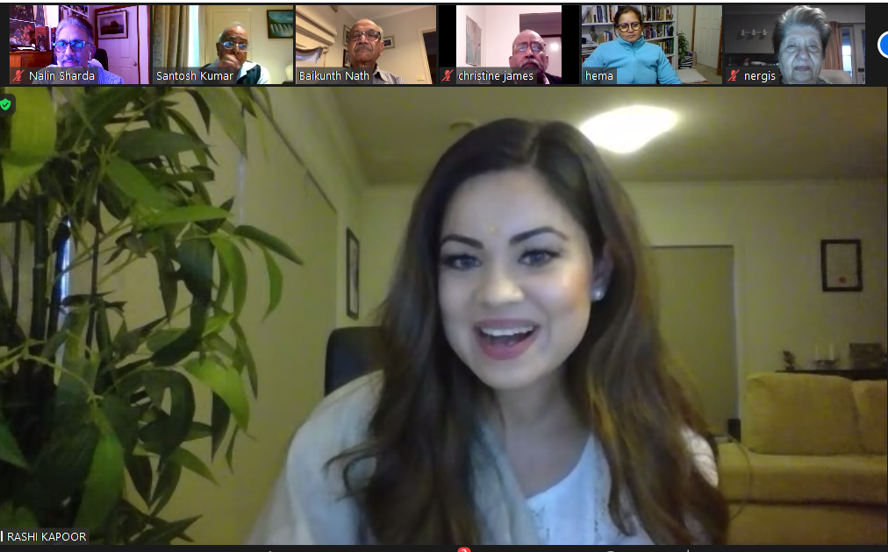
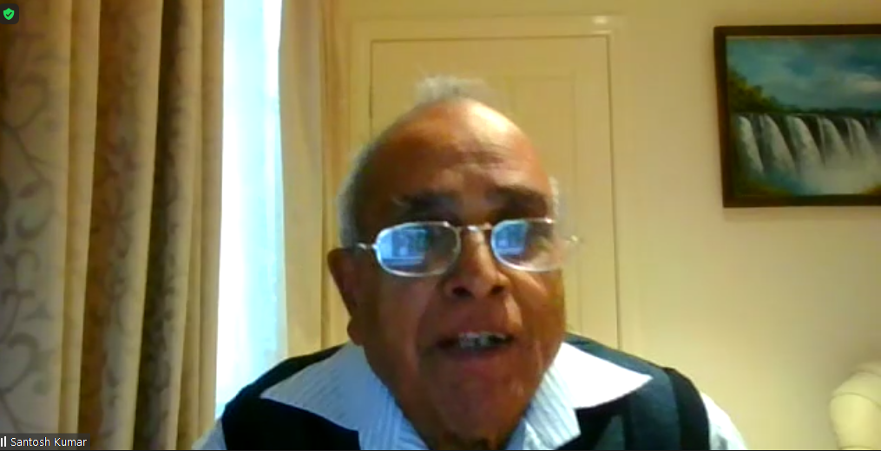

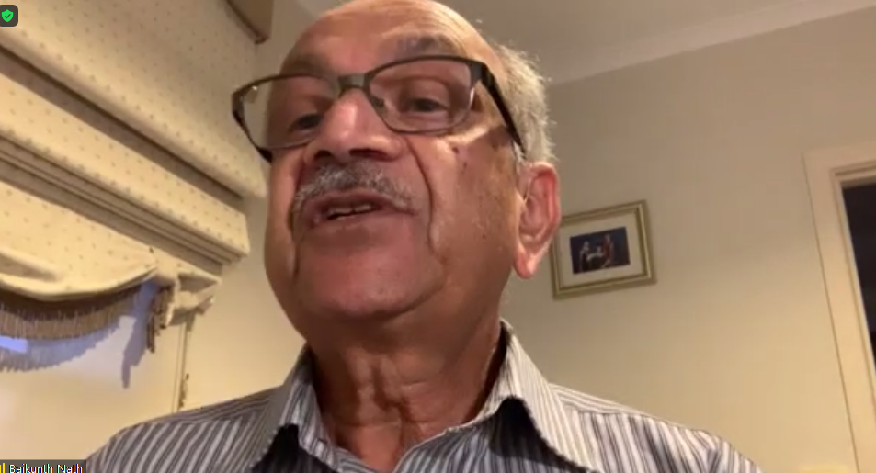

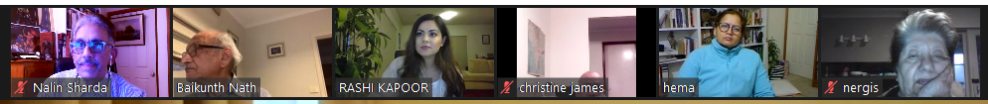
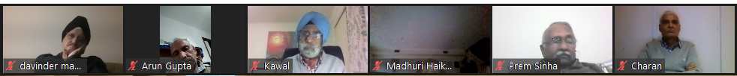
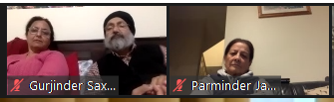

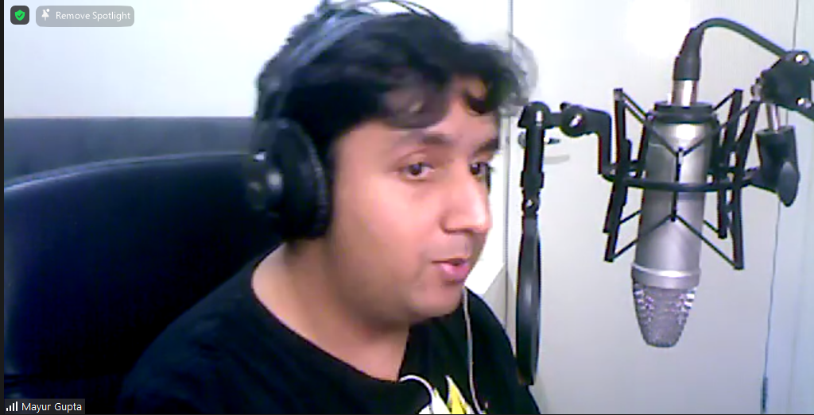

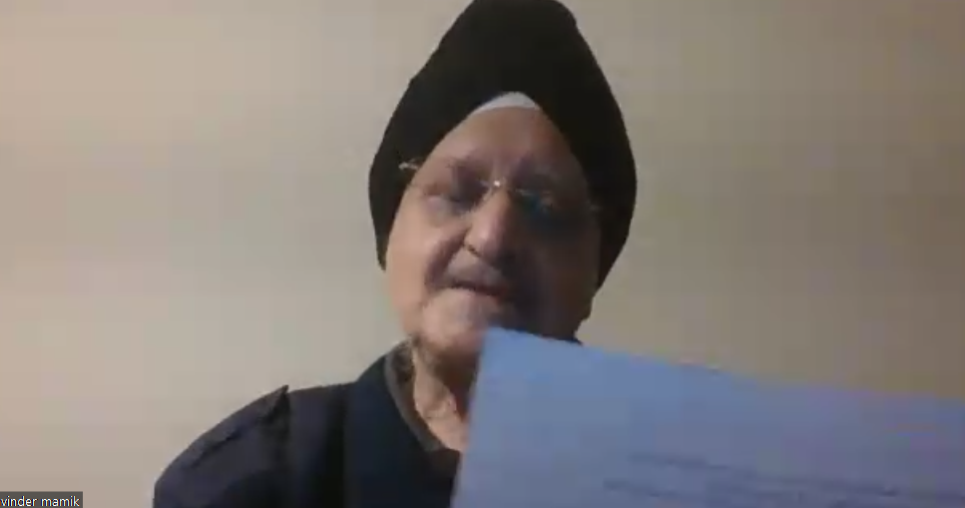

From Kirit & Minakshi Kapadia to Everyone: 04:05 PM
Namaskar to all. Santoshji OAM , congratulations.
From Vasan Venkataraman to Everyone: 04:54 PM
very useful. easy to follow. kind Regards
From Prem Sinha to Me: (Direct Message) 04:58 PM
am I the only one who cannot now see your power point? or your screen?
From mnath to Everyone: 05:35 PM
Hi All, The reception from my device is very bad, I am going to leave. Thanks for putting on a fantastic show.
From Gurjinder Saxena to Everyone: 05:36 PM
congratulations Dr. Santosh Ji for the award
From hema to Everyone: 05:41 PM
Rashi you were very good and taught us so much in a little time.
From Baikunth Nath to Everyone: 05:43 PM
Rashi Ji you were fantastic and super. Thank you and love
From RASHI KAPOOR to Everyone: 05:45 PM
Thank you so much for making me a part of NRISA's family. What an honour to be a part of NRISA's Yoga Day! Love and regards

